CROSS-DATASET GENERALISATION AND CALIBRATION ANALYSIS OF STROKE RISK PREDICTION MODELS
ABSTRACT Stroke is a leading cause of disability and mortality worldwide, yet machine learning models developed for stroke risk prediction are rarely evaluated beyond the datasets on which they were trained. This study investigates the generalisation of stroke prediction models by training three classifiers namely Logistic Regression, Random Forest and XGBoost, on the Kaggle Stroke Prediction Dataset and evaluating them externally on a harmonised cohort from the National Health and Nutrition Examination Survey (NHANES) 2021–2023 without any retraining. A four-feature harmonisation pipeline covering age, gender, body mass index (BMI) and average glucose level was constructed with all preprocessing parameters estimated exclusively from the source domain. Under deployment conditions, the Receiver Operating Characteristic Area Under the Curve (ROC-AUC) declines by 12–15% across all models, with non-overlapping 95% bootstrap confidence intervals confirming statistical significance. The Precision Recall Area Under the Curve (PR-AUC) collapses by 51–63%, revealing near-trivial minority-class detection in the target population. Multi-method distributional shift analysis using Population Stability Index (PSI), Kolmogorov-Smirnov (KS) tests and a domain classifier identify severe input feature shift in age and glucose, while label shift is non-significant. Feature patching experiments confirm that correcting distributional differences consistently worsens performance, providing evidence of concurrent concept shift. Post-hoc calibration via Platt scaling and isotonic regression yields no recovery. These findings demonstrate that PR-AUC is the appropriate evaluation metric for rare-event prediction under population mismatch and that rigorous feature-level measurement documentation is a prerequisite for valid external validation in clinical machine learning.
Keywords: Cross-domain generalisation, stroke risk prediction, dataset shift, external validation, calibration analysis
1. INTRODUCTION
Stroke remains a principal cause of permanent disability and premature mortality worldwide, sustaining considerable research interest in machine learning-based risk stratification (Akinwumi et al., 2025; Fan et al., 2025; Melnykova et al., 2025; Sutcu et al., 2025). The Kaggle Stroke Prediction Dataset has become one of the most widely used benchmarks in the field, with classifiers achieving ROC-AUC values between 0.80 to 0.98 (Chakraborty et al., 2024; Hassan et al., 2024; Sutcu et al., 2025). These results represent genuine methodological progress, but they share a critical blind spot. Almost all published models are evaluated on held-out partitions of their own training data which results in uncharacterised behaviour on independent populations (Lee et al., 2023; Ryu et al., 2022).
Deployed clinical models encounter patients whose demographics, measurement instruments and comorbidity distributions may differ from the training source. Dataset shift encompasses three distinct failure mechanisms, namely covariate shift, where feature distributions change, label shift, where class prevalences differ and concept shift, where the feature-label relationship itself. Temporal studies conducted within hospital settings (Guo et al., 2021) and evaluations across multiple clinical sites (Ryu et al., 2022) confirms that such degradation happens consistently and with similar trends documented in stroke-adjacent prediction tasks (Fan et al., 2025; Zhong et al., 2025).
Class-balancing strategies, which are standard when there is a big difference in the number of strokes, raise the chances of a positive class and affect calibration before any change in the domain happens (Huang et al., 2020). Post-hoc methods such as Platt scaling (Platt, 1999) are often suggested as potential solution, however, their effectiveness under substantial distributional mismatch is poorly established (Li et al., 2025; Zhou et al., 2025).
This study addresses these gaps through the first systematic cross-domain evaluation of Kaggle-trained stroke classifiers against NHANES 2021–2023 dataset. The evaluation includes performance measurement through bootstrap confidence intervals, multi-method shift decomposition, calibration analysis, feature-patching for concept shift detection and post-hoc adaption evaluation. The principal finding is that PR-AUC, rather than ROC-AUC, more precisely depicts the degree of deployment failure in rare-event prediction situations (Akinwumi et al., 2025; Salmi et al., 2024).
Section two reviews prior studies, section three presents the research gaps, section four describes the methodology, section five reports experimental results and sections six and seven provide conclusions and future directions.
2. PRIOR STUDIES
The existing work on machine learning for stroke prediction spans three areas, namely benchmark model development and evaluation, class imbalance management and cross-dataset generalisation with domain adaptation.
2.1 Stroke Prediction and In-Domain Evaluation
Sutcu et al. (2025) provide a multi-method analysis on the Kaggle Stroke Prediction Dataset, combining clustering, classification and survival modelling with XGBoost emerging as the best-performing classifier on in-domain metrics. On the same data, Chakraborty et al. (2024) achieve 98.6% accuracy through a stacked ensemble with principal component analysis-based dimensionality reduction and Hassan et al. (2024) consistently identify age, glucose and cardiovascular history as dominant predictors across multiple classifier configurations. Large prospective cohort studies replicate this pattern at scale. Chun et al. (2021) develop stroke risk models from 0.5 million Chinese adults and Duan et al. (2025) from a regional health information system, both restricting evaluation to the development population. Huang and Liu (2025) apply a similar workflow to NHANES data by training and validating within the same survey cycle without testing against an external source. Approaches incorporating augmentation and deep architectures, such as Saleem et al. (2025) for stroke and Khan et al. (2025) for cardiovascular risk, improve minority-class recall but share the same in-domain evaluation constraint.
2.2 Class Imbalance in Clinical Prediction
Stroke datasets typically present fewer than five percent positive cases, hence, making imbalance handling unavoidable. Melnykova et al. (2025) demonstrate that standard classifiers fail to detect stroke cases reliably under these conditions and recommend cost-sensitive alternatives whereas, Araf et al. (2024) specifically examine cost-sensitive learning for imbalanced medical data while documenting that it can improve recall but may compromise calibration quality and Salmi et al. (2024) provide a decade long systematic review confirming that the interaction between balancing method and evaluation metric is non-trivial and that ROC-AUC routinely masks minority-class detection failure. Carriero et al. (2024) add a cautionary qualification through simulation which states that, imbalance corrections can actively harm model performance under certain conditions, including those where the correction distorts predicted probabilities relative to the target prevalence. This result is directly relevant to the class_weight = balanced configuration used in this study. Sheetal et al. (2025) also found a similar problem in predicting cardiovascular disease, where high accuracy co-exists with clinically significant failure on positive cases.
2.3 Cross-Dataset Generalisation and Domain Adaptation
Silva et al. (2025) review strategies for detecting and mitigating dataset shift in health machine learning, covering population shift, temporal drift and measurement incompatibility as distinct mechanisms and identify PSI and KS tests among the most operationally useful diagnostics. Lee et al. (2023) show that standard empirical risk minimisation produces fragile models under distributional change and propose stable prediction approaches for electronic health records. Ryu et al. (2022) conduct an evaluation of a clinical model implemented in multiple emergency departments, finding performance variation across sites despite identical model weights, this finding raises questions regarding the cross-institutional applicability of the model in practice. Guo et al. (2021) demonstrate that even temporal shift within a single institute degrades model output in ways which is not attributable to label shift alone. Lu et al. (2025) establish that PSI values in medical datasets may be dominated by variation in measurement protocol rather than demographic change, with direct implications for interpreting the glucose shift statistics reported in this study.
Domain adaptation approaches like semi-supervised alignment (Li et al., 2025) and source-free methods (Zhou et al., 2025) achieve modest AUC recovery under moderate covariate shift, but these methods assume covariate shift as the primary mechanism, which the present study challenges through concept shift analysis. External validation for stroke-adjacent tasks has been demonstrated by Zhong et al. (2025), who validate a post-stroke cognitive impairment model across independent cohorts and Fan et al. (2025), who document substantial degradation of stroke survival models outside the development site. Akinwumi et al. (2025) show that metric selection substantially changes conclusions about relative model utility and Matta et al. (2024) provide a systematic review of generalisation challenges in medical image classification whose implications extend directly to tabular prediction. Huang et al. (2020) propose a calibration measurement framework for clinical prediction models. The post-hoc recalibration methods such as isotonic regression and Platt scaling (Platt, 1999) are widely used, although their effectiveness remains context dependent and their performance under domain shift is often limited.
3. MOTIVATION AND RESEARCH GAPS
3.1 Motivation
Models trained on the Kaggle Stroke Prediction Dataset have shown ROC-AUC scores up to 0.98. These figures are cited as supporting evidence for clinical utility (Chakraborty et al., 2024; Hassan et al., 2024; Sutcu et al., 2025). But, such metrics cannot determine if learned decision boundaries are valid beyond the training distribution.. Clinical decision support systems encounter patients with different demographic compositions, measurement instruments and institutional practices that differ from those present at training phase. This gap between controlled benchmark evaluation and real-world deployment motivates a direct empirical test of generalisation on an independent nationally representative cohort.
3.2 Research Gaps
Three specific gaps remain unaddressed. First, no prior study has evaluated Kaggle-trained stroke models against a nationally representative independent population survey. Even large-scale cohort studies such as Chun et al. (2021) and Huang and Liu (2025) evaluate only within the development population and this pattern persists across the benchmarking literature (Chakraborty et al., 2024; Sutcu et al., 2025). Held-out in-distribution evaluation cannot determine whether learned patterns transfer to populations with different demographics, sampling methods or clinical measurement protocols. Second, ROC-AUC dominates evaluation in this field, yet under severe class imbalance it is well established that ROC-AUC masks substantial minority-class detection failure (Salmi et al., 2024; Sheetal et al., 2025). For classifiers operating at 4–5% stroke prevalence, PR-AUC offers a more clinically meaningful performance criterion and studies reporting both metrics find that rankings and conclusions can differ markedly depending on which is used (Akinwumi et al., 2025; Araf et al., 2024). Third, measurement protocol differences between datasets are routinely treated as administrative details rather than scientific confounds. The glucose variable demonstrates this risk: NHANES records fasting plasma glucose under standardised conditions, while Kaggle's average glucose level is of unspecified collection type. The resulting apparent shift to a PSI of 1.495 in this analysis cannot be remediated by any adaptation technique and must be documented as a primary confound rather than corrected (Li et al., 2025; Lu et al., 2025). This study addresses all three gaps through a controlled cross-domain evaluation protocol with rigorous shift decomposition.
4. METHODOLOGY
This section describes the complete experimental methodology. It covers the study design, source and target datasets, feature harmonisation procedure, preprocessing decisions, model configurations, evaluation protocol, shift analysis framework, mathematical definitions of all key quantities, a notation reference table and the two algorithms governing the experimental pipeline. All design decisions prioritise strict source-only training to ensure a valid deployment simulation.
4.1 Study Design
This study follows a source-to-target evaluation approach in which classifiers are trained exclusively on the Kaggle dataset and evaluated without retraining on a harmonised NHANES cohort. The complete pipeline encompasses five phases: data ingestion, preprocessing, model training, cross-domain evaluation and shift analysis. The dashed boundary indicates that NHANES is held out throughout training.

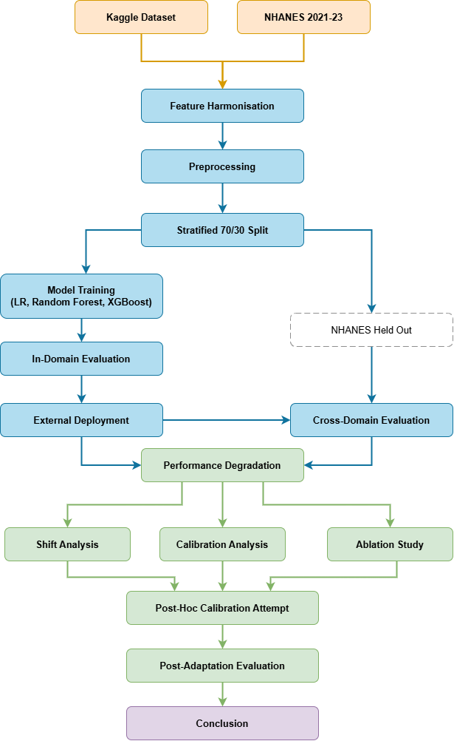

Figure 1. Cross-domain evaluation pipeline. The diagram shows the five-phase workflow from data ingestion through shift analysis. The dashed box indicates that NHANES is held out throughout training.
4.2 Datasets
4.2.1 Source Domain
The Kaggle Stroke Prediction Dataset comprises 5,109 records (one removed for an unrecognised gender value) with 11 features and a stroke prevalence of 4.87%. The dataset lacks documentation of its clinical provenance and label ascertainment procedure.
4.2.2 Target Domain
NHANES 2021–2023 modules DEMO_L, BMX_L, GLU_L and MCQ_L were merged and filtered to adults aged 18 and above with valid stroke labels, fasting glucose, BMI and gender, yielding N = 3,167 with a stroke prevalence of 4.10%. Glucose missingness is structural in NHANES; non-fasting participants are not tested and was therefore not imputed.
4.3 Feature Harmonisation
Four features were mapped across datasets: age, gender, BMI and average glucose level. The mapping is detailed in Table 1. A critical measurement mismatch exists for glucose. NHANES records fasting plasma glucose exclusively while Kaggle's variable is of unspecified type, likely post-meal. This is documented as a primary confound rather than a correctable pipeline error.

Table 1. Feature harmonisation mapping between Kaggle and NHANES.
Kaggle Variable | NHANES Variable | Status | Notes
age | RIDAGEYR | Harmonised | Continuous; restricted to adults 18 and above
gender | RIAGENDR | Harmonised | Male = 1, Female = 0 in both datasets
bmi | BMXBMI | Harmonised | Continuous; both in kg/m²
avg_glucose_level | LBXGLU | Harmonised | Fasting plasma (NHANES) vs. unspecified type (Kaggle). Measurement mismatch documented as primary confound
stroke | MCQ160F | Harmonised | Binary label; Kaggle ascertainment undocumented
hypertension | BPXO_L | Excluded | Self-report (Kaggle) vs. measured blood pressure (NHANES); not equivalent
heart_disease | MCQ_L | Excluded | No equivalent variable with matching ascertainment
smoking_status | SMQ_L | Excluded | Kaggle 'Unknown' category not mappable to NHANES encoding
work_type | N/A | Excluded | No equivalent in NHANES
ever_married | N/A | Excluded | Outside scope of shift analysis
residence_type | N/A | Excluded | No equivalent in NHANES

4.4 Mathematical Formulation
Covariate shift occurs when the marginal feature distribution differs between source and target domains while the conditional label distribution remains stable:

$$P_{S}\left(X\right)≠P_{T}\left(X\right), P_{S}\left(Y \right| X)= P_{T}(Y | X))$$ | (1)

Concept shift occurs when the relationship between features and labels differs across domains:

$$P_{S}\left(Y \right| X) ≠ P_{T}\left(Y \right| X)$$ | (2)

The Population Stability Index (PSI) quantifies distributional shift magnitude, where E_{i} and A_{i} are bin proportions for Kaggle and NHANES respectively (M = 10 bins). Thresholds: <0.10 stable; 0.10–0.20 moderate; >0.20 severe:

$$PSI= \sum_{i=1}^{M}{\left(A_{i}-E_{i}\right)⋅}\ln\left(\frac{A_{i}}{E_{i}}\right)$$ | (3)

The generalisation gap measures performance loss under domain shift, where $f$ is trained on $D_{S}^{train}$ only:

$$∆_{gap} =AUC\left(f; D_{S}^{test}\right)-AUC\left(f; D_{T}\right)$$ | (4)

Average Precision (AP) is computed from predicted probabilities, where P_{n} and R_{n} are precision and recall at threshold n. AP is preferred over ROC-AUC as it is sensitive to minority-class detection failure under class imbalance:

$$AP= \sum_{n=1}^{N}{\left(R_{n}-R_{n-1}\right)⋅P_{n}}$$ | (5)

The Expected Calibration Error (ECE) uses ten uniform bins (K = 10), where acc(S_{k}) and conf(S_{k}) are the fraction of positives and mean predicted probability in bin S_{k}:

$$ECE= \sum_{k=1}^{K}{\frac{\left|S_{k}\right|}{n}}\left|acc\left(S_{k}\right)-conf\left(S_{k}\right)\right|$$ | (6)

Bootstrap confidence intervals use B = 1,000 resamples (seed = 42), where $θ_{b}^{*}$ is the metric on the b-th resample:

$${CI}_{95}= \left[Q_{0.025}\left(θ_{1}^{*},…,θ_{B}^{*}\right), Q_{0.975}\left(θ_{1}^{*},…,θ_{B}^{*}\right)\right]$$ | (7)

4.5 Notation Reference
Table 2. Notations and descriptions.
Notation | Description | Notation | Description
$$D_{S}$$ | Source domain (Kaggle training dataset) | P_{n} | Precision at the n-th decision threshold
$$D_{T}$$ | Target domain (NHANES 2021–2023 cohort) | R_{n} | Recall at the n-th decision threshold
$$D_{S}^{train}$$ | 70% stratified Kaggle training split (seed=42) | S_{k} | Set of samples in the k-th confidence bin
$$D_{S}^{test}$$ | 30% held-out Kaggle test split | acc(S_{k}) | Fraction of positive instances in bin S_{k}
$$f$$ | Classifier trained on D_{S}^{train} only; not retrained on D_{T} | conf(S_{k}) | Mean predicted probability in bin S_{k}
Δ_{gap} | Larger value indicates greater performance loss under domain shift | b | Index of a single bootstrap resample (b=1,…,B)
$$E_{i}$$ | Proportion of Kaggle observations in bin i | B | Total bootstrap resamples (B=1,000, seed=42)
$$A_{i}$$ | Proportion of NHANES observations in bin i | $$θ_{b}^{*}$$ | Value of the evaluation metric on resample b
P_{S}(X) | Marginal feature distribution, source domain | P_{T}(X) | Marginal feature distribution, target domain
P_{S}(Y | X) | Conditional label distribution, source domain | P_{T}(Y | X) | Conditional label distribution, target domain

4.6 Preprocessing
IterativeImputer (max_iter = 10, seed = 42) and StandardScaler were fitted exclusively on the Kaggle training split and applied unchanged to the Kaggle test set and NHANES cohort. A stratified 70/30 split (seed = 42) produced a training set of N = 3,576 and a test set of N = 1,533.
4.7 Models
Three classifiers were trained with class imbalance handling: Logistic Regression (C = 1.0, class_weight = balanced), Random Forest (n_estimators = 200, max_depth = 6, class_weight = balanced) and XGBoost (n_estimators = 200, max_depth = four, learning_rate = 0.1, scale_pos_weight = 19.6).
4.8 Evaluation Protocol
Performance was measured using ROC-AUC, PR-AUC computed directly from predicted probabilities as defined in Eq. (5), Brier score and Expected Calibration Error (ECE) as defined in Eq. (6). All metrics include 95% bootstrap confidence intervals per Eq. (7) computed over 1,000 stratified resamples (seed = 42).
4.9 Shift Analysis
Distributional shift was characterised using KS tests for per-feature marginal shift, PSI per Eq. (3) for shift magnitude and a Random Forest domain classifier distinguishing Kaggle from NHANES samples via cross-validated AUC. Label shift was assessed by chi-square test on stroke prevalence across both datasets.
4.10 Algorithms
4.10.1 Algorithm 1: Cross-Domain Generalisation Evaluation
Input: Kaggle dataset, NHANES dataset, features = {age, gender, bmi, avg_glucose_level}, classifiers = {Logistic Regression, Random Forest, XGBoost}.
Output: ROC-AUC, PR-AUC, Brier Score, ECE with 95% confidence intervals for both domains.

1. Map shared features across Kaggle and NHANES
2. Split Kaggle: 70% training, 30% test (stratified, seed = 42)
3. Fit imputer and scaler on Kaggle training set only
4. Apply fitted imputer and scaler to Kaggle test set and NHANES
5. for each classifier:
Train on Kaggle training set with class balancing
6. for each classifier:
Generate predicted probabilities on Kaggle test set and NHANES
Compute ROC-AUC, PR-AUC, Brier Score, ECE
Compute 95% confidence intervals via 1,000 bootstrap resamples
Compute generalisation gap = Kaggle AUC minus NHANES AUC
7. for each feature:
Compute KS statistic and PSI between Kaggle train and NHANES
Train domain classifier to distinguish Kaggle vs. NHANES samples
8. for each classifier:
Apply Platt scaling on Kaggle training set; evaluate on NHANES
Apply isotonic regression on Kaggle training set; evaluate on NHANES

Return: all metrics, confidence intervals, shift statistics, adaptation results
Algorithm 1 covers the complete evaluation pipeline, from source-domain preprocessing and classifier training through cross-domain performance measurement, distributional shift quantification and post-hoc calibration testing. It is designed to quantify how much performance degrades under domain shift, but cannot determine whether that degradation originates from covariate shift or concept shift, which is addressed in Algorithm 2.
4.10.2 Algorithm 2: Shift Contribution Analysis
Input: Trained XGBoost model, Kaggle training set (scaled), NHANES set (scaled), NHANES labels.
Output: Change in NHANES AUC per feature when covariate shift is corrected.

1. Compute baseline AUC on NHANES using trained model
2. for each feature:
Copy the NHANES set
Replace the current feature column with values sampled from the Kaggle training
distribution
Compute new AUC on the patched NHANES set
Compute delta = patched AUC minus baseline AUC
3. if all delta values are negative:
Concept shift is confirmed

Return: feature name, patched AUC and delta for each feature
Algorithm 2 implements a feature-patching procedure that isolates each feature's contribution to the generalisation gap and provides empirical evidence of concept shift by testing whether correcting covariate shift in each feature improves or worsens cross-domain performance.
5. EXPERIMENTS
All experiments were conducted using Python 3.10 with scikit-learn 1.7.2 and XGBoost 2.0. Three classifiers, Logistic Regression, Random Forest and XGBoost, were trained on the Kaggle training split and evaluated on both the Kaggle test set and the NHANES cohort. No target-domain labels were used at any stage. All random operations used seed = 42. The per-model discrimination and calibration behaviour is presented below in three sub-sections, each covering ROC curves, precision-recall curves and calibration curves for a single classifier across both domains. The significant gap between domains across all curve types confirms that cross-domain failure is common to all model families as observed in sections 5.1, 5.2 and 5.3.
5.1 Logistic Regression
The ROC curve shows a clear drop from an AUC of 0.838 in-domain to 0.713 cross-domain, as shown in Figure 2a. The precision-recall curve reveals a more severe collapse, with average precision falling from 0.214 to 0.079 shown in Figure 2b. The calibration curve shows substantial deviation from the diagonal in both domains shown in Figure 2c.
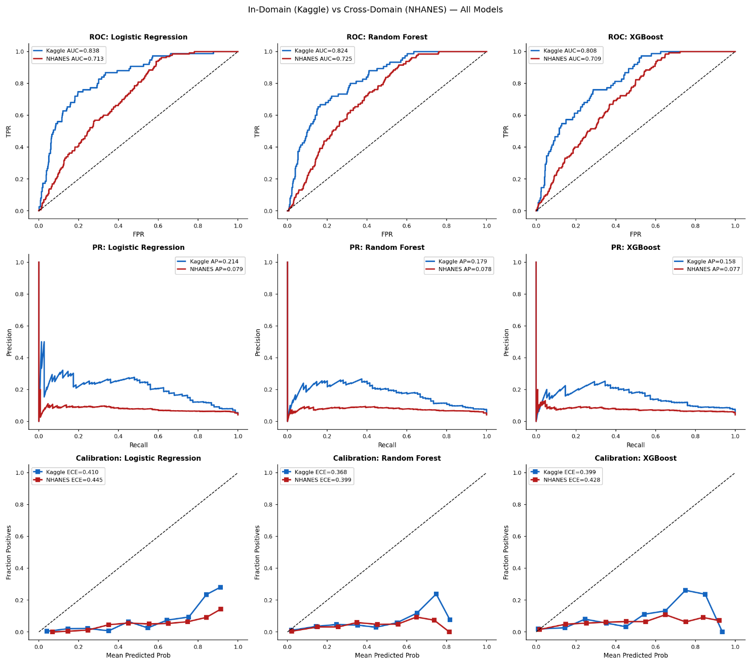  Figure 2a. ROC curve for Logistic Regression on Kaggle (in-domain) and NHANES (cross-domain). | Figure 2b. PR curve for Logistic Regression on Kaggle and NHANES. | 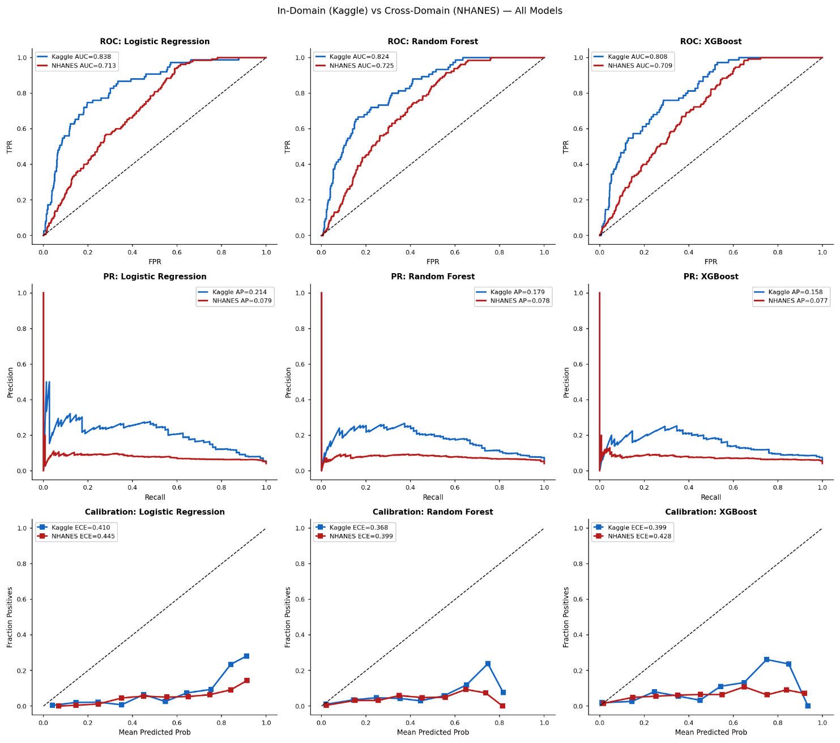  Figure 2c. Calibration curve for Logistic Regression on Kaggle and NHANES.
5.2 Random Forest
In case of Random Forest classifier, the ROC-AUC declines from 0.824 to 0.725 under domain shift shown in Figure 3a and average precision drops from 0.179 to 0.078, a 56% reduction shown in Figure 3b. The calibration pattern mirrors that of Logistic Regression, with pre-existing miscalibration worsening modestly under domain shift shown in Figure 3c.

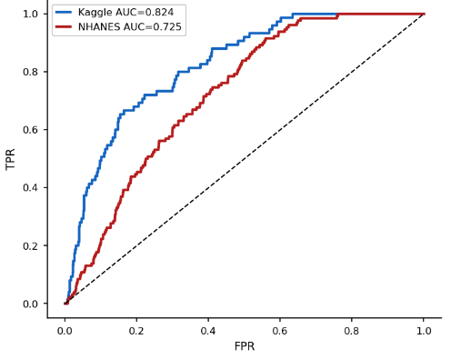  Figure 3a. ROC curve for Random Forest on Kaggle and NHANES. | 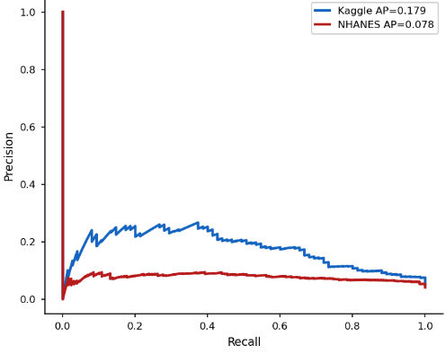  Figure 3b. PR curve for Random Forest on Kaggle and NHANES. | Figure 3c. Calibration curve for Random Forest on Kaggle and NHANES.
5.3 XGBoost
XGBoost exhibits a comparable pattern of degradation , despite being the strongest model in absolute in-domain terms ROC-AUC = 0.808. With cross-domain ROC-AUC falling to 0.709 shown in Figure 4a and average precision collapsing from 0.158 to 0.077, a 51% reduction shown in Figure 4b. Also, XGBoost shows the lowest Brier score in-domain but retains poor calibration under domain shift, consistent with the other classifiers shown in Figure 4c.

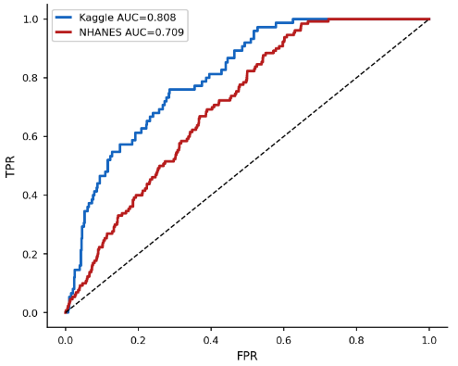  Figure 4a. ROC curve for XGBoost on Kaggle and NHANES. | 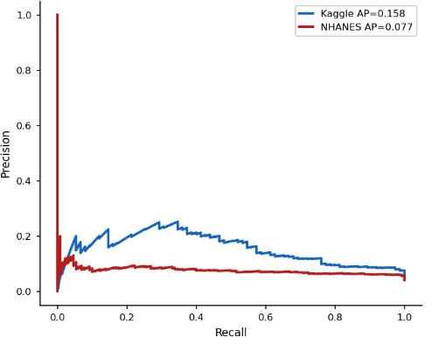  Figure 4b. PR curve for XGBoost on Kaggle and NHANES. | 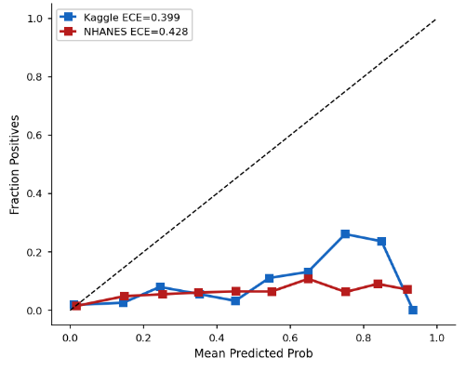Figure 4c. Calibration curve for XGBoost on Kaggle and NHANES.

5.4 In-Domain vs. Cross-Domain Performance
Under in-domain evaluation on the Kaggle test set, all three classifiers achieve ROC-AUC values in the range 0.808 to 0.838. Under cross-domain evaluation on NHANES the ROC-AUC drops from 0.709 to 0.725, representing a 12-15% relative decline. Most importantly, the confidence intervals do not overlap between domains for any model, confirming that the degradation is statistically significant and not attributable to sampling variability. Table 3 presents the full evaluation results with 95% bootstrap confidence intervals across both domains.

Table 3. In-domain and cross-domain evaluation results. K = Kaggle test set; N = NHANES cohort.
Model | ROC-K | ROC-N | PR-K | PR-N | Brier-K | Brier-N | ECE-K | ECE-N
Logistic Regression | 0.838 | 0.713 | 0.214 | 0.079 | 0.175 | 0.269 | 0.41 | 0.445
Random Forest | 0.824 | 0.725 | 0.179 | 0.078 | 0.132 | 0.185 | 0.368 | 0.399
XGBoost | 0.808 | 0.709 | 0.158 | 0.077 | 0.098 | 0.123 | 0.399 | 0.429

In-domain PR-AUC ranges from 0.158 to 0.214, reflecting meaningful minority-class detection. Under domain shift, PR-AUC collapses from 0.077 to 0.079 across all models, which corresponds to a relative reduction of 51-63%. At NHANES prevalence of 4.1%, a random classifier achieves average precision of approximately 0.041 however, the cross-domain models achieve only 1.9 times this baseline and indicates near-trivial minority-class utility. Error bars represent 95% bootstrap confidence intervals (n = 1,000) and non-overlapping intervals confirm statistically significant degradation across all models. This discrepancy between ROC-AUC and PR-AUC degradation establishes that ROC-AUC is a misleading primary metric for cross-domain evaluation of rare-event classifiers (Figures 5 and 6).

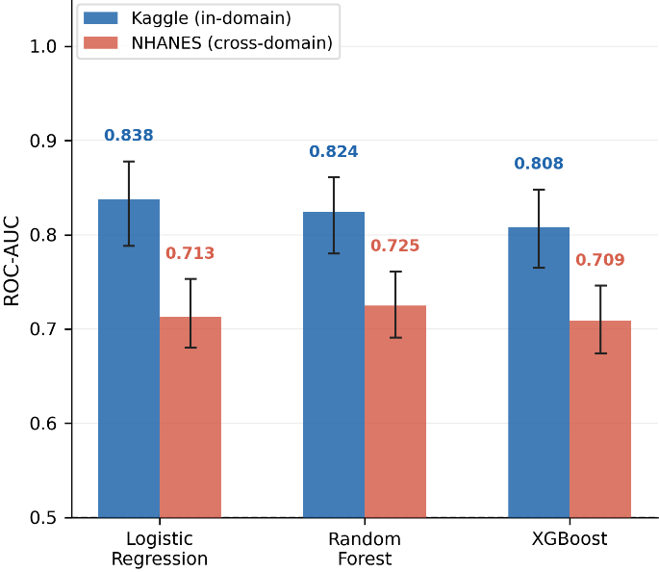  Figure 5. ROC-AUC comparison across all three classifiers for in-domain (Kaggle) and cross-domain (NHANES) evaluation. | 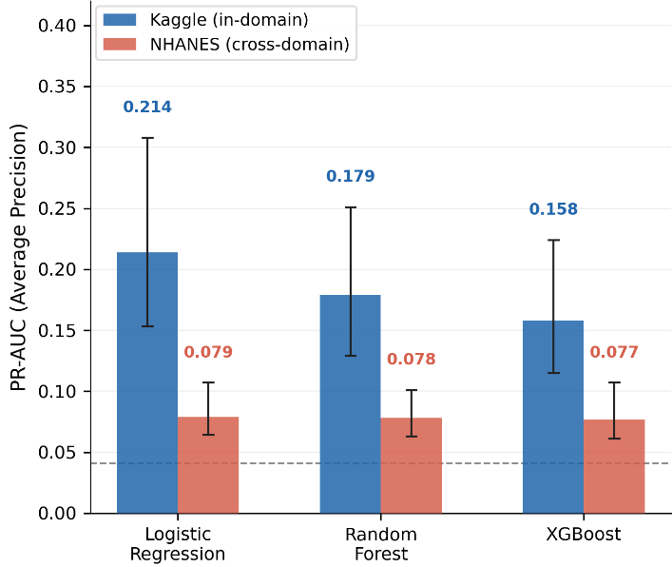  Figure 6. PR-AUC comparison across all three classifiers for in-domain (Kaggle) and cross-domain (NHANES) evaluation.

The absolute magnitude of the PR-AUC collapse is illustrated in Figure 7, which shows relative drops of 63%, 56% and 51% for Logistic Regression, Random Forest and XGBoost respectively, this consistent pattern is not observable by ROC-AUC alone.. In-domain models achieve 3.2×-4.4× the random baseline, whereas cross-domain models consistently achieve 1.9×, indicating that stroke detection utility is substantially degraded within the target population. The corresponding lift ratio comparison is shown in Figure 8

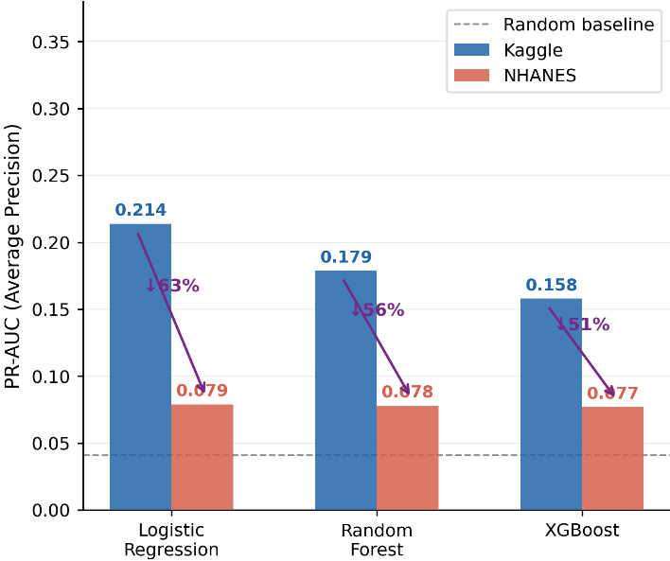  Figure 7. PR-AUC collapse under domain shift for all three classifiers. | 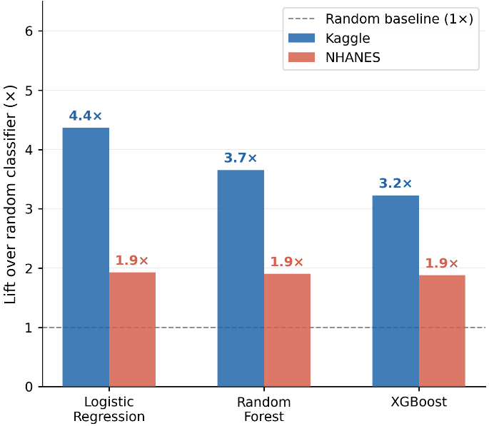  Figure 8. Lift ratio over the random classifier baseline for Kaggle and NHANES across all models.

High in-domain ECE values of 0.368-0.410 reflect probability distortion from class_weight = balanced, which inflates positive-class predictions relative to the actual 4.9% prevalence. The modest cross-domain ECE increase of 0.03-0.04 is therefore not the primary calibration concern, as miscalibration was already present before domain shift occurred. Brier score and ECE results across all models and both domains are shown in Figure 9 and Figure 10.

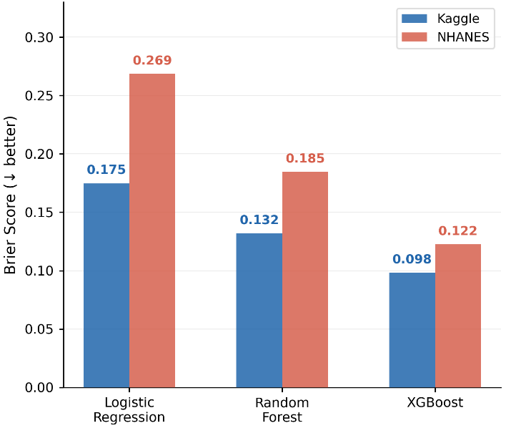  Figure 9. Brier score for all three classifiers on Kaggle and NHANES. | 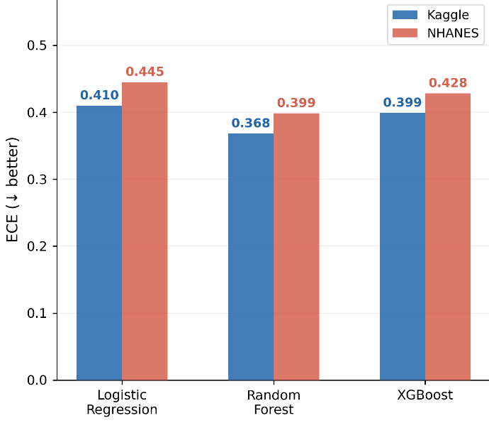  Figure 10. Expected Calibration Error for all three classifiers on Kaggle and NHANES.
5.5 Shift Analysis
Two features age (PSI = 1.007) and average glucose level (PSI = 1.495) exhibit severe distributional shift. Gender is stable (PSI = 0.004; KS p = 0.057) so not significant, while BMI shows moderate shift (PSI = 0.105). The domain classifier achieves a cross-validated AUC of 0.858 $±$ 0.014, which indicates a strong joint distribution shift between the datasets. Label shift is non-significant (χ² p = 0.149), ruling out prior probability shift as the primary explanation for performance degradation. Per-feature shift statistics are reported in Table 4.

Table 4. Feature-level shift analysis results. n.s. = not significant
Feature | KS Statistic | KS p-value | PSI | Severity
age | 0.207 | 2.1×10⁻⁶³ | 1.007 | Severe
gender | 0.032 | 0.057 (n.s.) | 0.004 | Stable
bmi | 0.088 | 1.4×10⁻¹¹ | 0.105 | Moderate
avg_glucose_level | 0.362 | 1.4×10⁻¹⁹⁵ | 1.495 | Severe

The glucose exhibits a PSI of 1.495 which exceeds severe shift threshold by a factor of 7.5. This reflects a mismatch in measurement protocol rather than a true population-level difference. NHANES LBXGLU records fasting plasma glucose exclusively, while Kaggle's average glucose level is of unspecified type most-likely post-meal or random. This mismatch cannot be corrected by any adaptation technique and is documented as a primary confound rather than a correctable pipeline error. The PSI and KS results are visualised in Figure. 11 and Figure. 12 respectively.

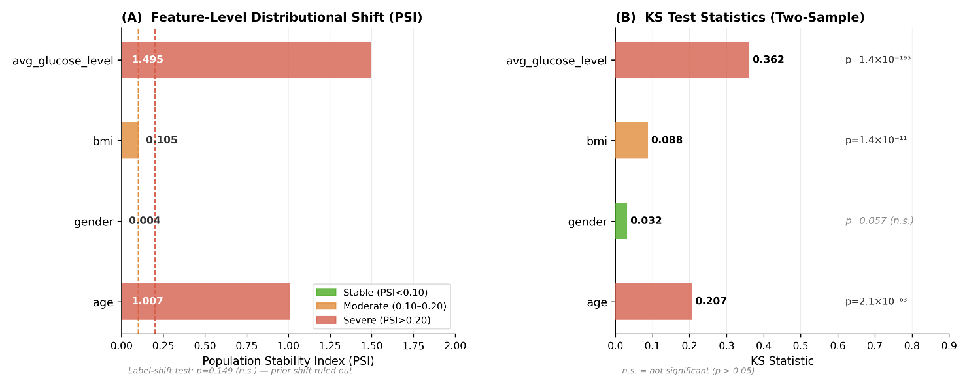  Figure 11. PSI per feature for the Kaggle–NHANES comparison. | Figure 12. KS test statistics per feature for the Kaggle–NHANES comparison.
The Principal Component Analysis (PCA) projection (Figure 13) shows NHANES samples extending further along PC1, the axis dominated by age, BMI and glucose, with two distinct bands corresponding to gender on PC2, visually confirming the severe covariate shift quantified in Table 4. Figure 14 complements this by colouring the same projection by stroke label; stroke cases are distributed across both bands with no clear separation, consistent with the non-significant label shift result.

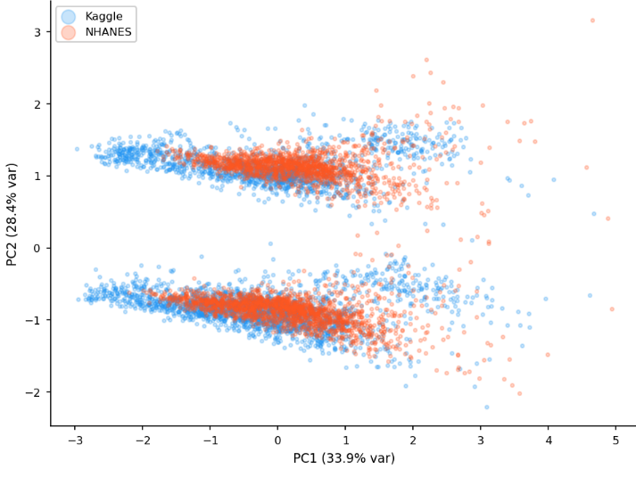  Figure 13. PCA projection of the combined Kaggle–NHANES feature space coloured by dataset membership. | 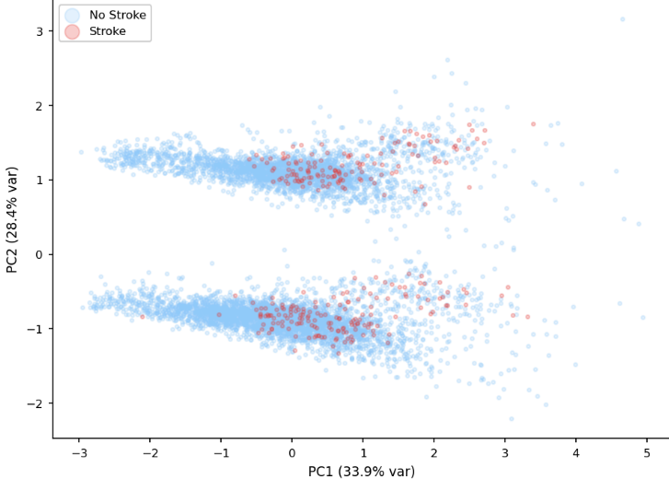  Figure 14. PCA projection of the combined Kaggle–NHANES feature space coloured by stroke label.
5.6 Ablation Study
No single feature removal closes the generalisation gap without collapsing overall performance, confirming that the gap is systemic rather than attributable to any individual feature. Removing BMI widens the generalisation gap from 0.099 to 0.113, while removing age narrows it to 0.067 at the cost of overall performance collapse. Together, these results confirm that no single feature is solely responsible for the cross-domain degradation and that BMI acts as a cross-domain stabilising feature despite its moderate PSI of 0.105. Removing glucose reduces the gap by only 0.002 despite its PSI of 1.495, providing direct evidence that shift severity as measured by PSI does not predict contribution to the generalisation gap. Results are illustrated in Figures 15 and 16. Table 5 presents ablation results for XGBoost.

Table 5. Ablation study results (XGBoost).
Configuration | Kaggle AUC | NHANES AUC | Gap | Observation
Full model (baseline) | 0.808 | 0.709 | 0.099 | Reference
w/o age | 0.602 | 0.535 | 0.067 | Gap narrows but AUC collapses
w/o gender | 0.793 | 0.702 | 0.091 | Negligible change
w/o bmi | 0.805 | 0.692 | 0.113 | Gap widens; BMI stabilises generalisation
w/o avg_glucose_level | 0.780 | 0.683 | 0.097 | Minimal change despite PSI = 1.495

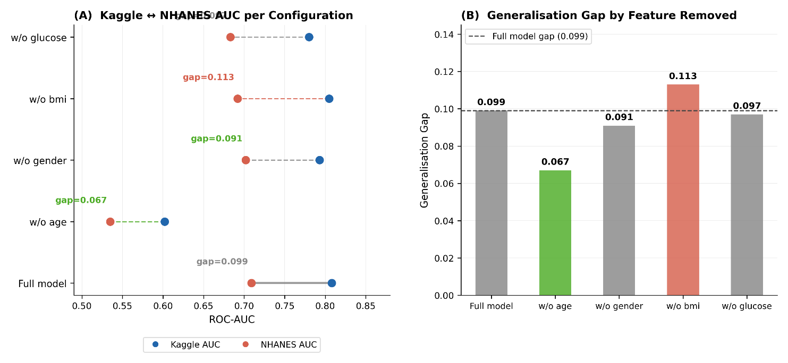  Figure 15. Dumbbell plot showing Kaggle and NHANES AUC for each leave-one-feature-out configuration of XGBoost. | Figure 16. Generalisation gap by feature removed for XGBoost
5.7 Concept Shift Evidence
The shift contribution analysis provides evidence of concurrent concept shift. For each feature in turn, NHANES values were replaced with samples drawn from the Kaggle training distribution and NHANES AUC was re-evaluated. If only covariate shift were present, aligning feature distributions would improve cross-domain performance. Instead, every patching operation reduced NHANES AUC (Figure 17). Patching age produced the largest degradation (0.709 to 0.509, δ = −0.200) while patching BMI and glucose produced smaller but consistent reductions. The universal negativity of all delta values provides direct empirical evidence that concept shift is present alongside covariate shift, as defined in Eq. (1) and Eq. (2) respectively.

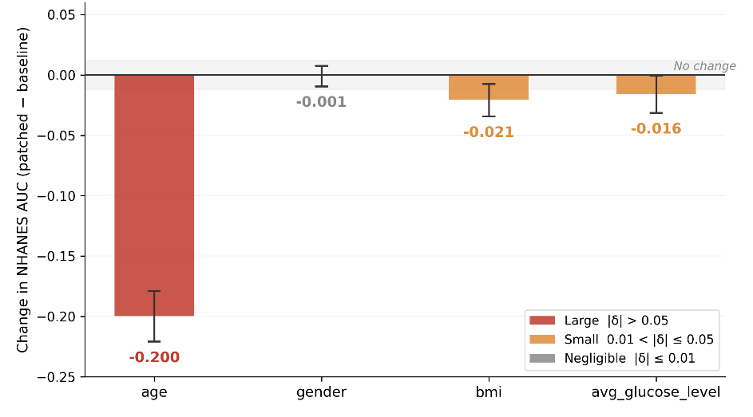
Fig.17. Shift contribution analysis

Platt scaling produces no change in AUC or PR-AUC across all three models. Isotonic regression is neutral for Logistic Regression but degrades Random Forest by 0.037 AUC points and catastrophically degrades XGBoost from 0.709 to 0.579 (Δ = −0.130), as shown in Figure 18. This failure is consistent with the concept shift finding: calibration methods adjust probability mappings but cannot alter the model's underlying discriminative behaviour when P(Y|X) has changed. Isotonic regression reduces XGBoost PR-AUC by 29% (Figure 19), confirming that post-hoc calibration cannot remediate concept shift when the conditional label distribution has changed across domains.

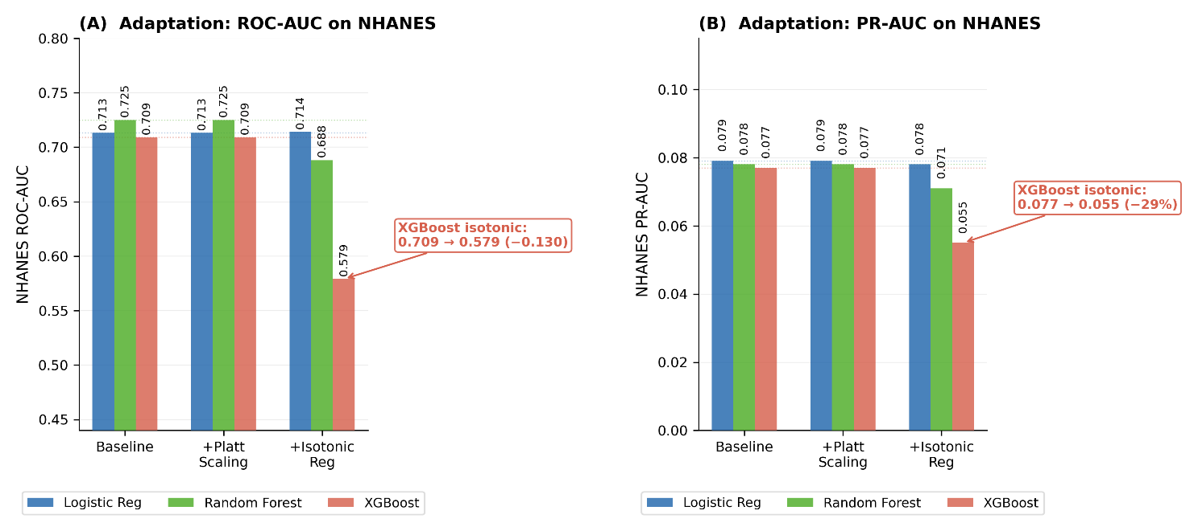  Figure 18. Post-hoc calibration results on NHANES showing ROC-AUC across all three models under baseline, Platt scaling and isotonic regression conditions. | Figure 19. Post-hoc calibration results on NHANES showing PR-AUC across all three models under baseline, Platt scaling and isotonic regression conditions.
5.8 Comparative Analysis
Comparison between the present study and Sutcu et al. (2025) across key experimental dimensions is shown in Table 6. Where that study reports gradient boosting ROC-AUC of 0.834 on an in-domain holdout whereas, the present study achieves 0.838 in-domain and 0.713 cross-domain ROC-AUC for Logistic Regression. The 0.125 absolute gap is driven by non-overlapping bootstrap confidence intervals and constitutes the study's central empirical contribution. Sutcu et al. (2025) report no PR-AUC whereas, the results of present study reveal a collapse from 0.214 to 0.079 under domain shift, a magnitude of degradation entirely invisible to ROC-AUC analysis alone. The 98.6% in-domain accuracy reported by Chakraborty et al. (2024) on the same Kaggle data reinforces this point, as held-out accuracy does not provide a reliable indication of performance on an independent population.

Table 6. Comparative analysis between the base paper and our study.
Dimension | Sutcu et al. (2025) | Present Study
Training Dataset | Kaggle Stroke Dataset (N = 5,110) | Kaggle Stroke Dataset (N = 5,109)
Evaluation Dataset | In-domain hold-out split (30%) | NHANES 2021–2023 (N = 3,167)
Evaluation Setting | In-distribution | Cross-domain
Primary Metrics | Accuracy, Recall, ROC-AUC | ROC-AUC, PR-AUC (95% CI)
Class Imbalance Handling | Not specified | class_weight = balanced, scale_pos_weight = 19.6
Best ROC-AUC | Gradient Boosting: 0.834 | Logistic Regression: 0.838 (Kaggle), 0.713 (NHANES)
PR-AUC | Not reported | Decline from 0.214 to 0.079 (≈63% reduction)
Shift Analysis | Not performed | KS test, PSI, domain classifier (AUC = 0.858)
Concept Shift Evaluation | Not performed | Patching analysis (all deltas negative)
Post-hoc Calibration | Not performed | Platt scaling and isotonic regression (ineffective)
Uncertainty Quantification | Not reported | 95% bootstrap CI (n = 1,000)
Key Finding | XGBoost achieves best in-domain trade-off | PR-AUC degradation >60%; ROC-AUC insufficient under shift
6. CONCLUSION
Stroke risk classifiers trained on the Kaggle benchmark exhibit statistically significant and practically consequential performance degradation when applied without retraining to NHANES 2021-2023 cohort. The ROC-AUC declines by 12-15% and the PR-AUC collapse by 51-63% indicates that minority-class detection, the clinically relevant task fails to a degree that ROC-based reporting becomes entirely misleading. The analysis of shift implicates severe covariate shift in age and glucose. The observed difference in glucose is likely due to the incompatibilities in measurement protocols rather than a population-level difference. Feature-patching experiments confirm concurrent concept shift and post-hoc calibration via Platt scaling and isotonic regression provides no recovery under these conditions.
The three conclusions we derive from these findings are as follows. First, in-domain hold-out evaluation is insufficient to establish clinical applicability and external validation against an independent population-representative dataset is a necessary condition. Second, PR-AUC should be reported as a primary metric for rare-event prediction tasks, as it is sensitive to the failure mode that domain shift induces while ROC-AUC is not. Third, feature-level measurement documentation specifying the exact measurement protocol for every variable is a methodological prerequisite for valid cross-dataset comparisons, not an optional supplement. Together, these findings constitute an empirical argument for a methodological shift in how clinical machine learning models are developed and reported, from benchmark optimisation toward deployment-aware evaluation, where external validity is tested rather than assumed.
7. FUTURE SCOPE
This study opens several productive directions for future work. The present study is restricted to the NHANES fasting glucose subsample which represents a specific morning clinic population. Extending the cohort to non-fasting participants or alternative surveys would broaden generalisability and expose cross-domain failure patterns across more diverse demographics. The glucose measurement mismatch identified here is fasting plasma glucose in NHANES against unspecified type in Kaggle reflects a wider problem in clinical ML. The absence of standardised feature provenance documentation across public datasets. A structured harmonisation protocol formally mapping clinical measurement definitions across widely used stroke and cardiovascular benchmarks would enable reproducible, scientifically defensible cross-dataset comparisons. On the methodological side, post-hoc calibration proves ineffective under concept shift, motivating adaptation strategies that operate at the representation level. Density ratio estimation and importance reweighting offer potential recovery of cross-domain performance without requiring labelled target data. Causal stability analysis following the framework proposed by Subbaswamy and Saria (2020) for building shift-stable models in health AI provides a principled path toward identifying features whose relationship with stroke outcomes remains invariant across populations enabling models that generalise by construction rather than coincidence. Collectively, these directions point toward a standard where clinical prediction models are evaluated and deployed with the rigour applied to pharmaceutical trials, where independent external validation is a prerequisite and not an afterthought.

8. REFERENCES

Akinwumi, P.O., Ojo, S., Nathaniel, T.I., Wanliss, J., Karunwi, O., & Sulaiman, M. (2025). Evaluating machine learning models for stroke prediction based on clinical variables. Frontiers in Neurology, 16. https://doi.org/10.3389/fneur.2025.1668420.
Araf, I., Idri, A., & Chairi, I. (2024). Cost-sensitive learning for imbalanced medical data: a review. Artificial Intelligence Review, 57. https://doi.org/10.1007/s10462-023-10652-8.
Carriero, A., Luijken, K., de Hond, A.A., Moons, K.G., van Calster, B., & van Smeden, M. (2024). The Harms of Class Imbalance Corrections for Machine Learning Based Prediction Models: A Simulation Study. Statistics in Medicine, 44. https://doi.org/10.1002/sim.10320.
Chakraborty, P., Bandyopadhyay, A., Sahu, P.P., Burman, A., Mallik, S., Alsubaie, N., Abbas, M., Alqahtani, M.S., & Soufiene, B.O. (2024). Predicting stroke occurrences: a stacked machine learning approach with feature selection and data preprocessing. BMC Bioinformatics, 25. https://doi.org/10.1186/s12859-024-05866-8.
Chun, M., Clarke, R.J., Cairns, B.J., Clifton, D.A., Bennett, D.A., Chen, Y., Guo, Y., Pei, P., Lv, J., Yu, C., Yang, L., Li, L., Chen, Z., & Zhu, T. (2021). Stroke risk prediction using machine learning: a prospective cohort study of 0.5 million Chinese adults. Journal of the American Medical Informatics Association : JAMIA, 28, 1719 - 1727. https://doi.org/10.1093/jamia/ocab068.
Duan, Y., Wang, R., Sun, Y., Zhu, W., Li, Y., Yu, N., Zhu, Y., Shen, P., & Sun, H. (2025). Development and validation of a stroke risk prediction model using regional healthcare big data and machine learning. International Journal of Nursing Sciences, 12, 558 - 565. https://doi.org/10.1016/j.ijnss.2025.10.011.
Fan, X., He, C., Xu, J., Ye, R., Zhao, J., & Wang, Y. (2025). Factors influencing short-term and long-term survival rates in stroke patients receiving enteral nutrition: a machine learning approach using MIMIC-IV database. BMC Neurology, 25. https://doi.org/10.1186/s12883-025-04201-9.
Guo, L.L., Pfohl, S.R., Fries, J.A., Johnson, A.E., Posada, J., Aftandilian, C., Shah, N.H., & Sung, L. (2021). Evaluation of domain generalization and adaptation on improving model robustness to temporal dataset shift in clinical medicine. Scientific Reports, 12. https://doi.org/10.1038/s41598-022-06484-1.
Hassan, A., Gulzar Ahmad, S., Ullah Munir, E., Ali Khan, I., & Ramzan, N. (2024). Predictive modelling and identification of key risk factors for stroke using machine learning. Scientific Reports, 14. https://doi.org/10.1038/s41598-024-61665-4.
Huang, J., & Liu, W. (2025). Development and validation of a machine learning model to predict stroke risk based on the NHANES database. Medicine, 104(45), e45800. https://doi.org/10.1097/MD.0000000000045800.
Huang, Y., Li, W., Macheret, F., Gabriel, R. A., & Ohno-Machado, L. (2020). A tutorial on calibration measurements and calibration models for clinical prediction models. Journal of the American Medical Informatics Association : JAMIA, 27(4), 621–633. https://doi.org/10.1093/jamia/ocz228.
Khan, M.J., Raza, B., & Faheem, M. (2025). RAVE-HD: A Novel Sequential Deep Learning Approach for Heart Disease Risk Prediction in e-Healthcare. Diagnostics, 15. https://doi.org/10.3390/diagnostics15222866.
Lee, S., Yin, C., & Zhang, P. (2023). Stable clinical risk prediction against distribution shift in electronic health records. Patterns, 4. https://doi.org/10.1016/j.patter.2023.100828.
Li, H., Wang, Y., & Qiang, Y. (2025). A semi-supervised domain adaptive medical image segmentation method based on dual-level multi-scale alignment. Scientific Reports, 15. https://doi.org/10.1038/s41598-025-93824-6.
Lu, S., Song, W., Pfob, A., & Gibbons, C. (2025). Assessing the representativeness of large medical data using population stability index. BMC Medical Research Methodology, 25. https://doi.org/10.1186/s12874-025-02474-9.
Matta, S., Lamard, M., Zhang, P., Guilcher, A.L., Borderie, L., Cochener, B., & Quellec, G. (2024). A systematic review of generalization research in medical image classification. Computers in biology and medicine, 183, 109256 . https://doi.org/10.1016/j.compbiomed.2024.109256.
Melnykova, N., Patereha, Y., Skopivskyi, S., Farion, M., Fedushko, S., & Drohomyretska, K. (2025). Machine learning for stroke prediction using imbalanced data. Scientific Reports, 15. https://doi.org/10.1038/s41598-025-01855-w.
Platt, J. (1999). Probabilistic Outputs for Support vector Machines and Comparisons to Regularized Likelihood Methods.
Ryu, A.J., Romero-Brufau, S., Qian, R., Heaton, H.A., Nestler, D.M., Ayanian, S., & Kingsley, T.C. (2022). Assessing the Generalizability of a Clinical Machine Learning Model Across Multiple Emergency Departments. Mayo Clinic Proceedings: Innovations, Quality & Outcomes, 6, 193 - 199. https://doi.org/10.1016/j.mayocpiqo.2022.03.003.
Saleem, M.A., Javeed, A., Akarathanawat, W., Chutinet, A., Suwanwela, N.C., Kaewplung, P., Chaitusaney, S., & Benjapolakul, W. (2025). Enhancing stroke risk prediction through class balancing and data augmentation with CBDA-ResNet50. Scientific Reports, 15. https://doi.org/10.1038/s41598-025-07350-6.
Salmi, M., Atif, D., Oliva, D., Abraham, A., & Ventura, S. (2024). Handling imbalanced medical datasets: review of a decade of research. Artificial Intelligence Review, 57. https://doi.org/10.1007/s10462-024-10884-2.
Sheetal, Deora, S.S., Haq, I.U., Rufai, S.Z., & Kumar, A. (2025). Evaluating Machine Learning Models for Cardiovascular Disease Prediction: Balancing Accuracy and Minority Class Detection. Archives of Computational Methods in Engineering. https://doi.org/10.1007/s11831-025-10383-9..
Silva, G.F., Filho, F.N., Wichmann, R.M., Junior, F.C., & Filho, A.C. (2025). Strategies for detecting and mitigating dataset shift in machine learning for health predictions: A systematic review. Journal of biomedical informatics, 104902. https://doi.org/10.1016/j.jbi.2025.104902.
Subbaswamy, A., & Saria, S. (2020). From development to deployment: dataset shift, causality, and shift-stable models in health AI. Biostatistics (Oxford, England), 21(2), 345–352. https://doi.org/10.1093/biostatistics/kxz041
Sutcu, M., Jouda, D., Yıldız, B., Katrib, J., & Almustafa, K.M. (2025). Predicting Stroke Risk Using Machine Learning: A Data-Driven Approach to Early Detection and Prevention. Stroke Research and Treatment, 2025. https://doi.org/10.1155/srat/2892726.
Zhong, X., Zhao, T., Lv, S., Zhang, G., Li, J., Liu, D., & Jiao, H. (2025). Development and validation of a machine learning-based risk prediction model for post-stroke cognitive impairment. Scientific Reports, 15. https://doi.org/10.1038/s41598-025-98054-4.
Zhou, J., Shi, Y., Qi, L., Jiang, X., Qi, S., & Qian, W. (2025). A3-DualUD: Source-free unsupervised domain adaptation via anatomical anchor alignment and dual-path uncertainty denoising for cross-modality medical image segmentation. Computer methods and programs in biomedicine, 271, 109017 . https://doi.org/10.1016/j.cmpb.2025.109017.

